**BINARY CLASSIFICATION ON ‘CUSTOMER_CHURN’ USING**

**KERAS**

**Table Of Contents**

**1.Probem Statement**

**2.Dataset Exploration**

**3.Data Manipulation**

**4.Data Visualization**

**5.Data Modelling**

**6.Infereneces**

**1)Problem Statement:**

You are the Data Scientist at a telecom company “Leo” whose customers are churning out to its

competitors. You have to analyse the data of your company and find insights and stop your customers from

churning out to other telecom companies.

**2)Customer Churn Dataset:**

Customer churn, also known as customer attrition, is when a customer chooses to stop using products or services of a company. But with each customer who churns, there are usually early indicators or metrics that can have been uncovered with churn analysis.

For example, The Telecom Industry faces a lot of Churn(With annual churn rate of 15-25%) because the customers can choose from a variety of service providers and actively switch from existing to another.

While looking at both Business operational insights (e.g. declining repeat purchases, reduced purchase quantity) and Customer experience insights along the customer feedbacks is foundational in order to predict churn. A scenario where a customer who has declined in recent visits and gives a feedback score of 6 of 10 after their latest shopping experience, could have an increased probability of churning**.**

In this Telecom Company's Data we have,

Churn Column - Customers who left recently

Services provided by the company to its customer – phone, multiple lines, internet, online security, online backup, device protection, tech support, and streaming TV and movies

Customer's Information Columns - Old/New Customer and their Active Period, contract, payment method, paperless billing, monthly charges, and total charges

Customer's Demographic Columns – gender, age range, and if they have partners and dependents

**3)Data Manipulation:**

a. Find the total number of male customers

**ANS:3555**

b. Find the total number of customers whose Internet Service is ‘DSL’

**ANS:2421**

c. Extract all the Female senior citizens whose Payment Method is Mailed check & store the

result in ‘new_customer’

**ANS: new_customer=df[((df['SeniorCitizen']==1) & (df['PaymentMethod']=='Mailed check') & (df['gender']=='Female'))]**

d. Extract all those customers whose tenure is less than 10 months or their Total charges is less than 500$ & store the result in ‘new_customer’

**ANS: new_customer=df[(df['tenure']<10) | (df['TotalCharges'] < 500)]**

**4)Data Visualization:**

a)Build a pie-chart to show the distribution of customers would be churning out

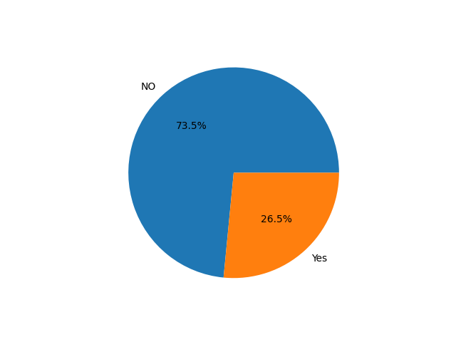

b)Build a bar-plot to show the distribution of ‘Internet Service’

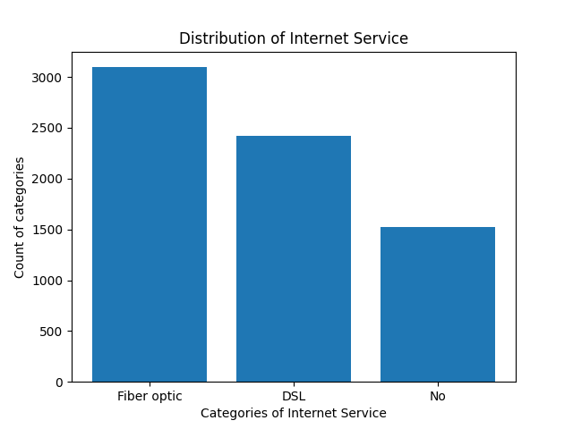

**The detailed Python code related to the above graphs has been attached with an ipynb file under in the zip file shared.**

**5)MODEL BUILDING:**

**a)Build a sequential model using Keras, to find out if the customer would churn or not, using ‘tenure’ as the feature and ‘Churn’ as the dependent/target column:**

i. The visible/input layer should have 12 nodes with ‘Relu’ as activation function.

ii. This model would have 1 hidden layer with 8 nodes and ‘Relu’ as activation function

iii. Use ‘Adam’ as the optimization algorithm

iv. Fit the model on the train set, with number of epochs to be 150

v. Predict the values on the test set and build a confusion matrix

vi. Plot the ‘Accuracy vs Epochs’ graph

**The detailed Python code related to the above graphs has been attached with an ipynb file under in the zip file shared along with the accuracies.Here I am attaching the accuracy vs epochs plot :**

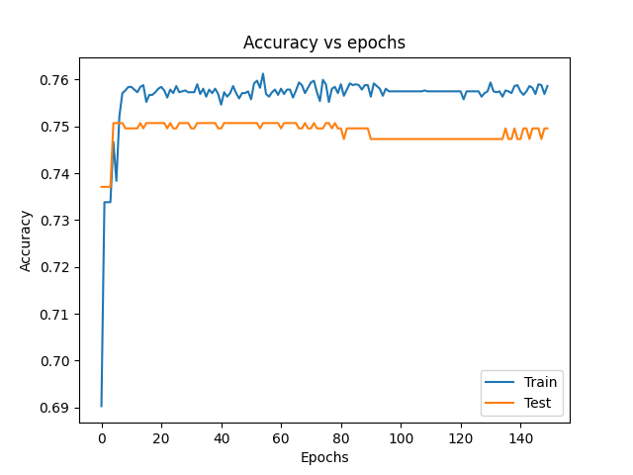

**b. Build the 2nd model using same target and feature variables:**

i. Add a drop-out layer after the input layer with drop-out value of 0.3

ii. Add a drop-out layer after the hidden layer with drop-out value of 0.2

iii. Predict the values on the test set and build a confusion matrix

iv. Plot the ‘Accuracy vs Epochs’ graph

A dropout layer has been added after the input and hidden layers has been done in the python code and adding the code in this platform might create a mess here, so I have shared the code in ipynb file attached in the zip form.However I am here by plotting the accuracy vs epochs plots for the above conditions.

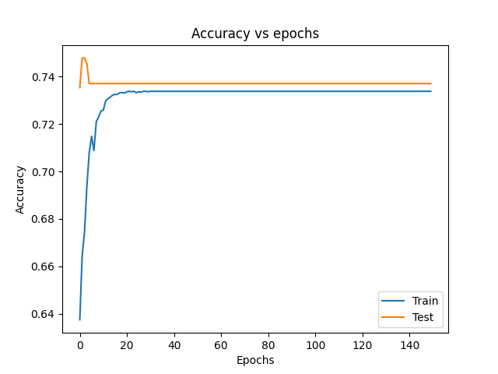

**c. Build the 3rd model using ‘Tenure’, ’Monthly Charges’ & ‘Total Charges’ as the features and ‘Churn’ as the dependent/target column:**

i. The visible/input layer should have 12 nodes with ‘Relu’ as activation function.

ii. This model would have 1 hidden layer with 8 nodes and ‘Relu’ as activation function

iii. Use ‘Adam’ as the optimization algorithm

iv. Fit the model on the train set, with number of epochs to be 150

v. Predict the values on the test set and build a confusion matrix

vi. Plot the ‘Accuracy vs Epochs’ graph.

Here in the attributes I have considered Tenure, Monthly charges and Total Charges and in the target column I have considered churn and performed the same process above.I am here by attaching the accuracy vs epochs graph.

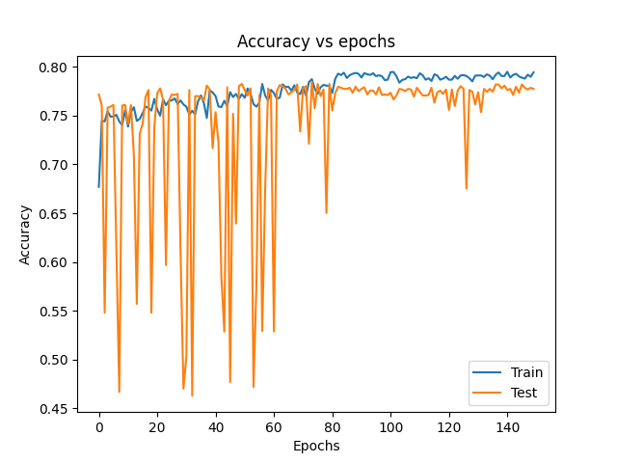

**6)INFERENCES:**

From the accuracies obtained with respect to different conditions given below, we can infer that neural networks models are effected by varius hyper parameters like addition of dropout layers for regularizations and also the impact of accuracy with the addition of few more fearures in the x list .

In the first model we have used the traidtional addition of layers without any dropout layer but in the second model we have used dropout layers andin the third model, we have used different attributes and compared the accuracies.